Project Development Phase
Model Performance Test

Date | 15 July 2026
Team ID | xxxxxx
Project Name | RBAC Workflow Simulator
Maximum Marks | 4 marks

Model Performance Testing:
Project team shall fill the following information in model performance testing template.
S.No. | Parameter | Values | Screenshot
 | Model Summary | RBAC Workflow Simulator developed to manage Users, Groups, Roles, ACLs, and Workflow Automation. The system validates user permissions, enforces access control policies, automates task assignments, sends notifications, and performs overdue task escalations. User impersonation is used to verify role-based access. | 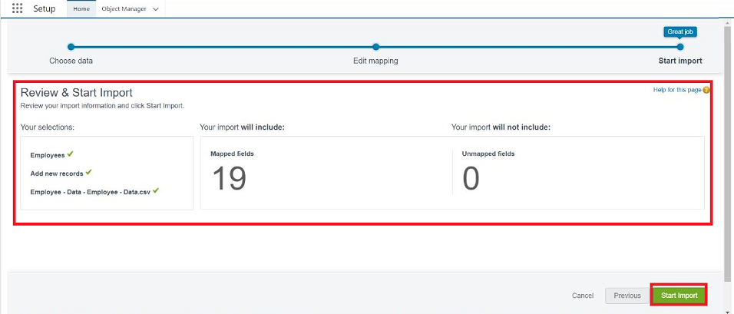
 | Accuracy | User Role Assignment Accuracy – 100%  ACL Validation Accuracy – 100%  Workflow Execution Accuracy – 98% | - 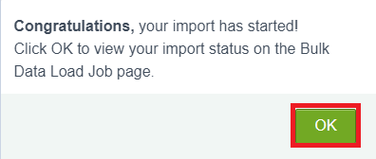
3. | Access Validation Score) | Authorized Access Detection – 100%  Unauthorized Access Prevention – 100%  User Impersonation Validation – Successful | 